**Analysis of Technology market sector (Provisional title)**

by: (write names and roles)

The objective of this paper is to analyze the technology market sector index (selecting a subset of the equities) applying regression modeling, specifically the CAPM model discussed in class. (add something)

To begin, we selected a sample of 26 equities available for at least ten years. The equities chosen for analysis are: CAPGEMINI, TIETOEVRY, LOGITECH 'R', HEXAGON B, SAGE GROUP, SOPRA STERIA GROUP, ASML HOLDING, BE SEMICONDUCTOR INDUSTRIES, NORDIC SEMICONDUCTOR, DASSAULT SYSTEMES, ASM INTERNATIONAL, SAP (XET), COMPUTACENTER, STMICROELECTRONICS (MIL), AIXTRON (XET), ALTEN, SOITEC, NEMETSCHEK (XET), INFINEON TECHS. (XET), BECHTLE (XET), REPLY, TEMENOS N, LAGERCRANTZ GROUP B, AMS-OSRAM AG, AMADEUS IT GROUP, FORTNOX AB

We opted to utilize two different short-term interest rates: the 3-month **Euribor** rate and the **Bund** rate. This decision was made to facilitate comparison, given the historical variations in these values, particularly during financial crises. The spread between these two rates can widen significantly under certain conditions.

Subsequently, we calculated the **returns** and **excess returns** for these equities. Next, we created scatter plots to visually compare these equities with the market index (Euro Stoxx 600 Europe). Our fisrt impression was that some of these equities exhibit apparent linear relationships. Below, we present six examples to illustrate our findings. The plots on the left indicate a direct connection with a linear relationship, while the ones on the right do not clearly demonstrate such a relationship.

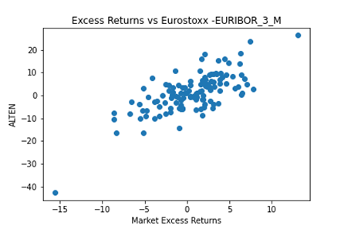

The analysis goes on calculating **Alpha, Beta** and they respective **p-values**:

A low p-value (close to 0) suggests that you can reject the null hypothesis, and that’s what happens with all the beta’s from our sample. In the barchart below we show that the values that we found are so low that aren’t even represented, being Aixtron the one with the higher p-value at 0.009, the not represented have a range which goes from  to .

That’s what we expected from the theory.

With regard to the alphas, we expect on the contrary to accept the null hypotesis, since the CAPM model postulates it to be equal to 0. The p-values that we found have a wider range of values, so we computed the mean, being this 0.357, and the choiche to accept or refuse would depend on the significance level. The values and the mean (in black) are represented in the following bar chart:

The last comparison was made between the average value of the parameters obtained for the single stocks (alfa,beta, p-value) and the values calculated on a equally weighted portfolio. The biggest difference can be found as we see on the calculus of the **R-squared**, which for the equally weighted portfolio reach a value much higher, indicating that our approximation is better fitting our values.

|  |  |  |
| --- | --- | --- |
|  | **Mean** | **Portfolio - EW** |
| **Alpha** | 0,731807 | 0,731806642 |
| **p-value_alpha** | 0,357078 | 0,013416917 |
| **beta: Market** | 1,255366 | 1,255366289 |
| **p-value_beta: Market** | 0,000368 | 1,29105E-34 |
| **R-Squared** | 0,310628 | 0,722239213 |

This is happenign probaly due to the fact that there are fluctuations or variations in the data that are purely due to chance. When you have more observations, these random fluctuations tend to cancel each other out, leading to a more stable and accurate estimate. In other words, as you increase the number of data points or observations, the impact of random, unpredictable fluctuations in the data becomes less significant because they cancell each other.

This is well represented in the following scatterplot, were in grey we have the scatterplots generated by all equities, in black the one of the equally weighted portfolio:

